Onderzoek verpakking
Ik dit onderzoek ga ik kijken wat er allemaal interessant is om in mijn verpakking te hebben.
Als ik aan een verpakking denk ik al snel aan een vierkante doos. Ik wil iets maken wat niet gewoon een doos is. Maar het moet nog wel stevig en functioneel zijn. Daarom wil ik misschien iets met 3 hoeken doen. Omdat het een stevige vorm is. En het kan ook mooi zijn als je het goed ontwerpt. Daarom hier was leuke 3 hoek ontwerpen
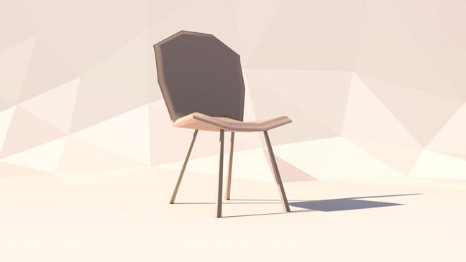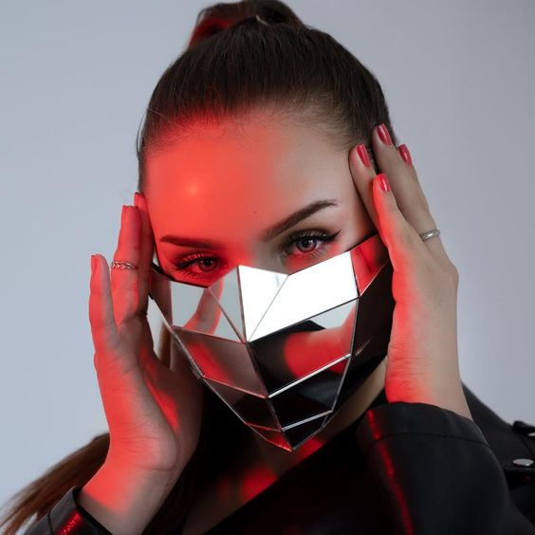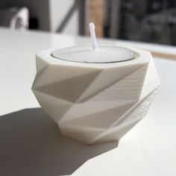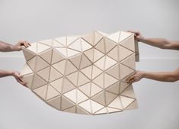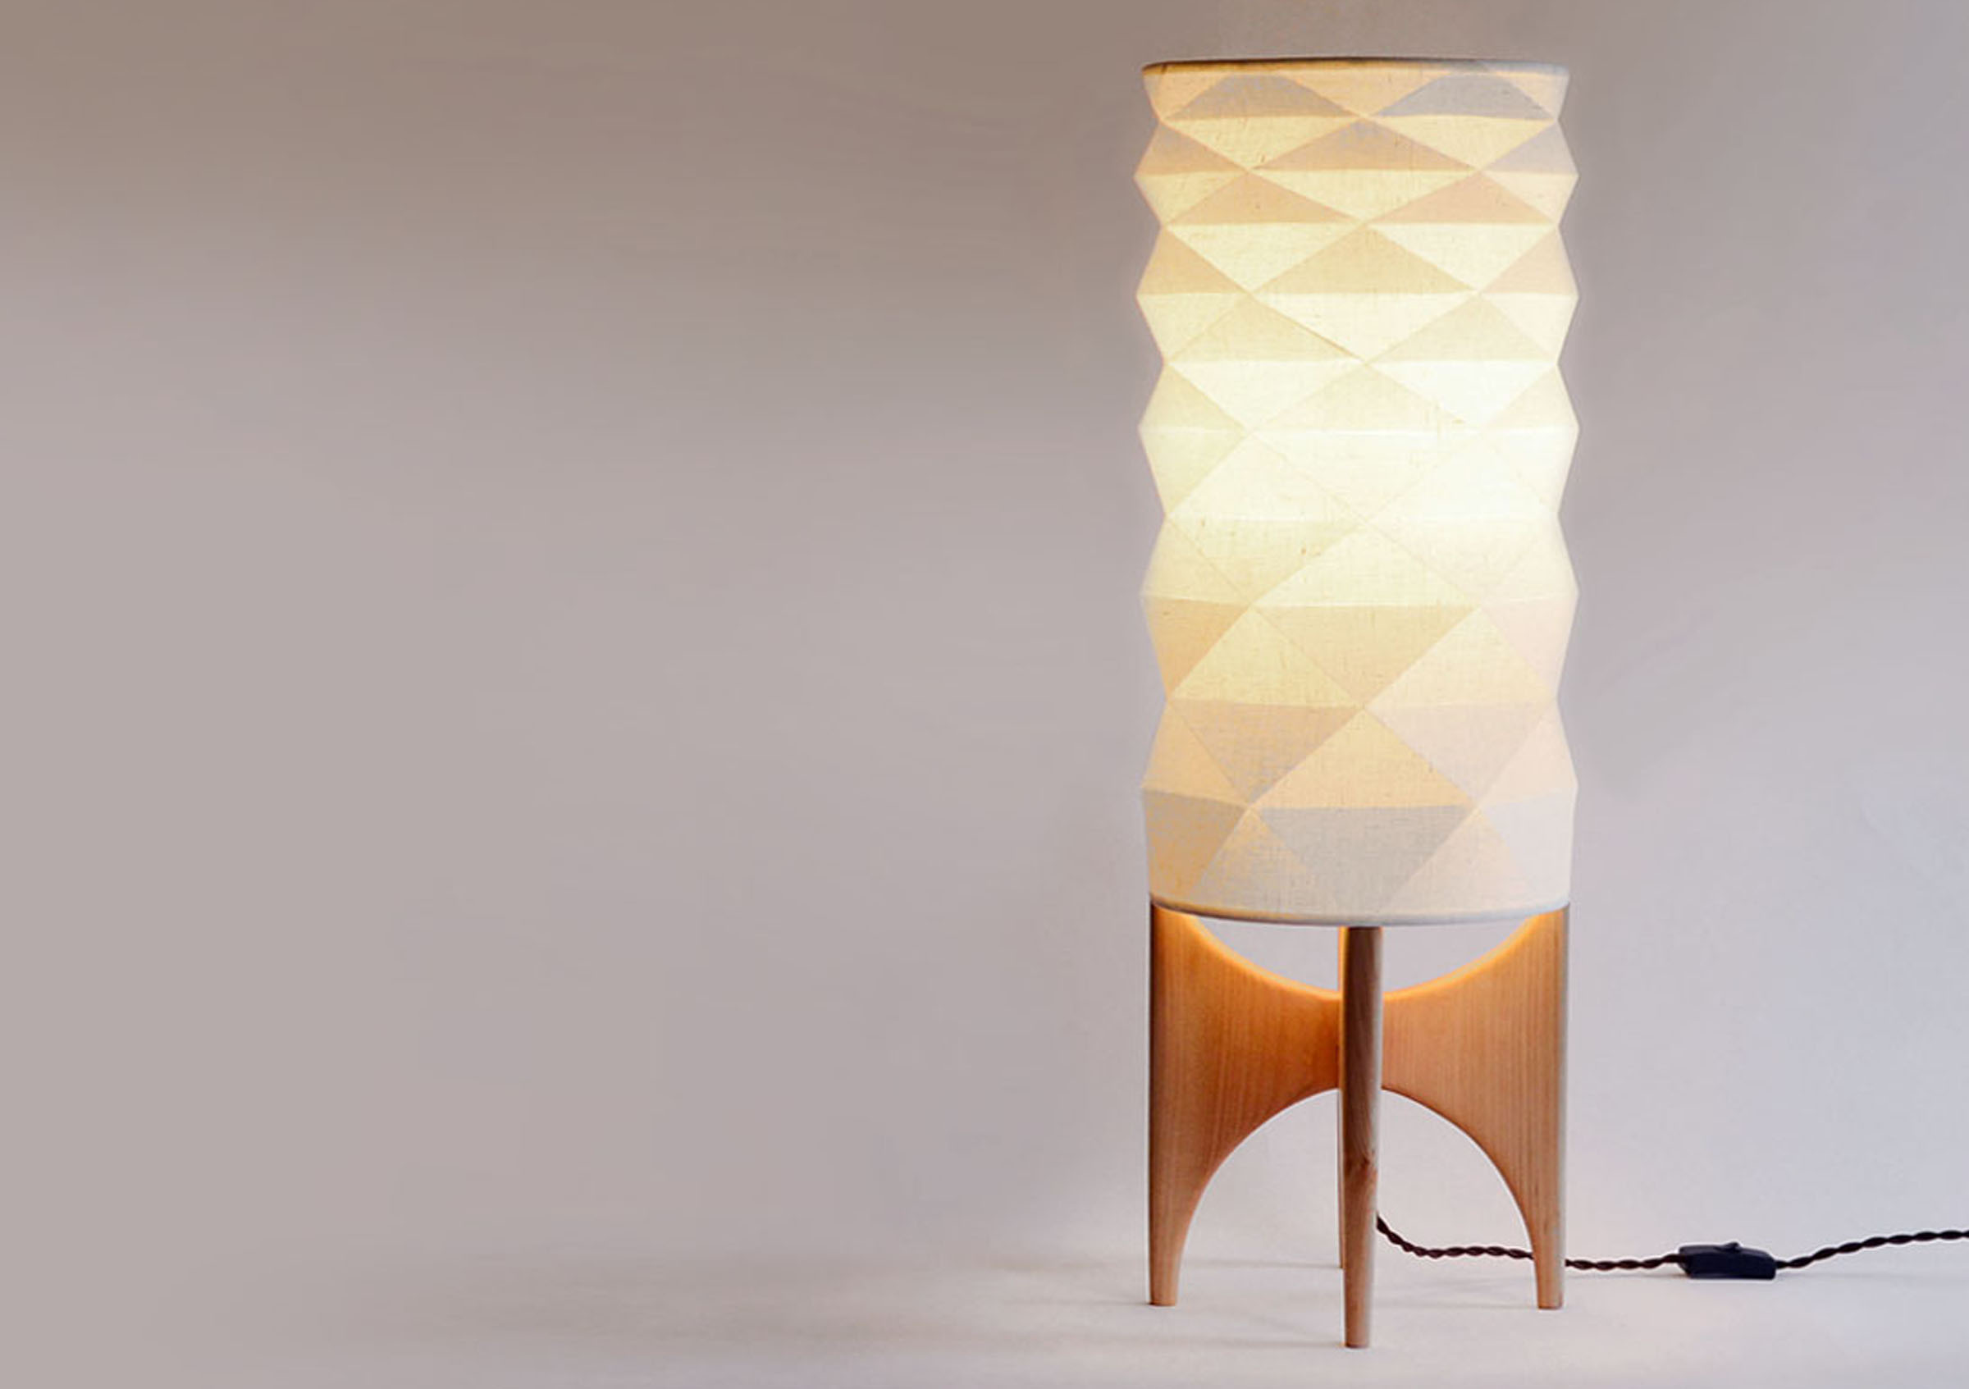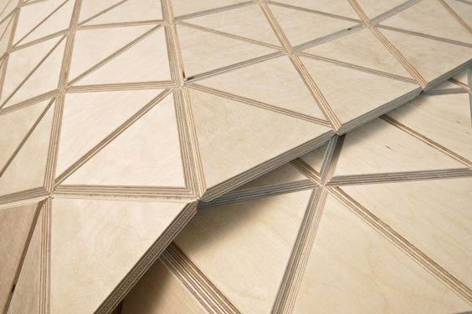

Ook ben ik gaan kijken wat je nou denkt bij verschillende vormen. Met deze vorm volgt je oog BV de lijn in het plaatje
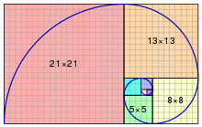
En zo heeft elke vorm zijn eigen betekenis.

Squares and Rectangles
These two shapes are thought to be the most commonly used. We see them many and many times per day. The walls and furniture, books or monitors, cell phones and cameras as well as many other everyday things have square or rectangular shapes. Straight lines and right angles of these two shapes give a sense of reliability and security. People strongly associate squares and rectangles with buildings the reason why they bring the feeling of trust and authority.
Common meanings:
- discipline
- strength
- courage
- security
- reliability
Photo App

Triangles
Triangle is an energetic and dynamic shape that is always associated with motion and direction. The lines are placed that way so our eyes automatically move to the top of a triangle or in the direction it is placed. Triangles can have different meanings. An upright triangle brings feelings of stability and balance but the reversed one looks risky and ready to fall giving people a sense of tense.
Common meanings:
- excitement
- risk
- danger
- balance
- stability

Circles, ovals, and ellipses
The first and foremost meaning of this shape is the eternity since they have no beginning or end. The circle has a long association with the sun and Earth as well as other cosmic objects while ellipse is similar to the whole universe. That’s why round shapes may give the feeling of magic and mystery. In addition, unlike the previous shapes circles don’t have angles so it makes them softer and milder.
Common meanings:
- eternity
- female
- universe
- magic
- mystery
Art Courses App

Spirals
These shapes can be often seen in nature, for example, shells and some flowers, the reason why it’s often associated with the circle of life and growth. Also, in some cultures, spirals may represent knowledge or information. In modern society, they are seen as a sign of creativity and a fresh mind.
Common meanings:
- growth
- creativity
- calmness
- intelligence
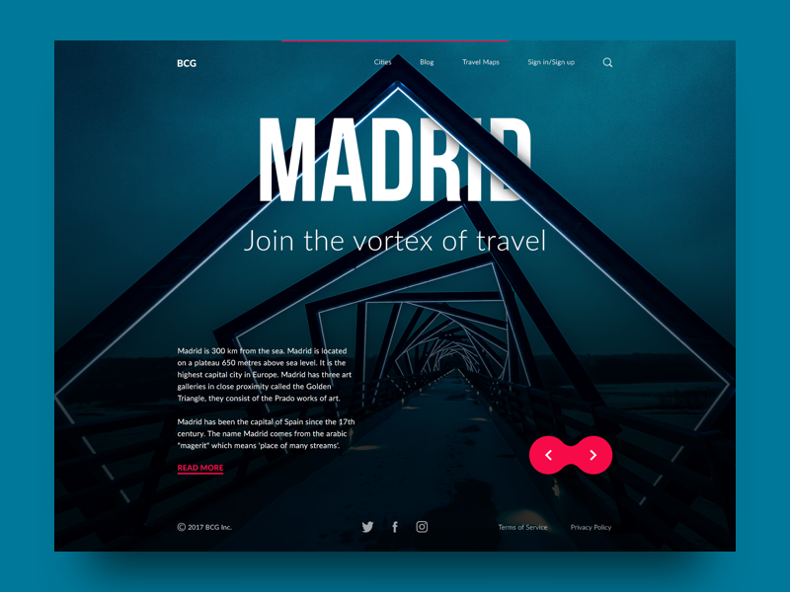
Big City Guide

Natural shapes meaning
All the things created by mother nature have a unique shape. Leaves, flowers, trees, animals, and many other representatives of flora and fauna become the source of inspiration for artists and designers. Natural shapes have clear meanings of the plants and animals which they symbolize. They often bring a feeling of refreshment and unity with the natural environment. In addition, animals and plants can also have their own characteristics and symbols. For example, a rose is a flower of love and passion, while a lion is a symbol of pride and bravery but this is another topic to discuss.
Common meanings:
- originality
- organic
- balance
- refreshment
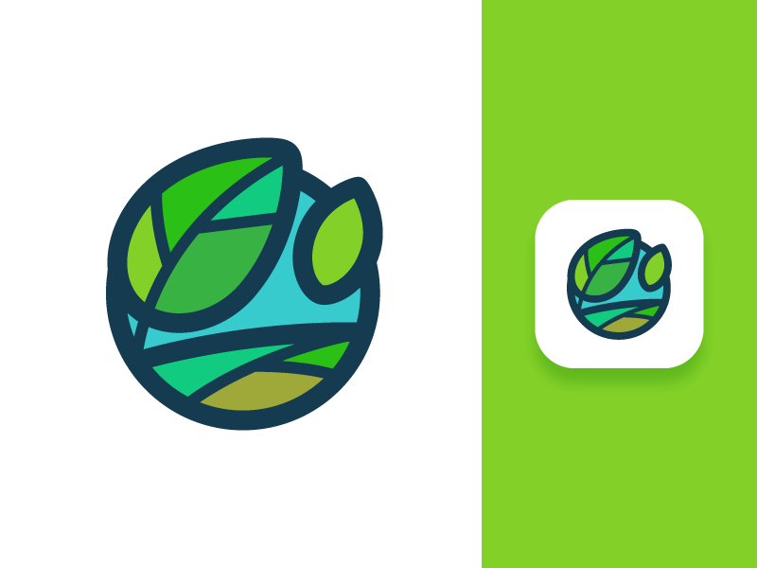
Andre landscape logo option

Abstract shapes meaning
They are usually visual symbols of abstract ideas or simplified versions of natural shapes. Some abstract shapes can be too difficult to recognize because they are stylized and only small details give a hint to what it is. One abstract shape often has both direct and figurative meanings. It is often used in graphic design, especially for logos and icons. Abstract shapes are an effective way to transfer a message quickly without text.
Common meanings:
- the duality of meaning
- uniqueness
- elaborate.
Ook heb ik gekeken hoe mijn doelgroep zich gedraagt. Mijn doelgroep is een Japans jong koppel en leeft in een rustig huis. Ik heb gekeken naar verschillende tradities die er in Japan zijn. Een van die tradities is theedrinken. Dat geeft rust en is goed voor de geest. Ook deden/doen Japanners aan dichten.

